1. =
2. A) B) C)
3. 3.5 hours + 5 hours + 6.5 hours = 15 hours worked

15 hours * $12.50/hour = $187.50

The student worked for 15 hours at $12.50 an hour for a total of $187.50.

1. 5.5 yards + 7.75 yards = 13.25 yards in total

13.25 yards – 3.25 yards = 10.00 yards

George purchased 13.25 yards of fabric and used 3.25 yards leaving him with 10.0 yards of fabric left.

The miller family has a total budget of $3958.33 a month based on $475 at 12%

Since we used 9% of the $18000 budget on the shrubs and flowers, we spent $1620.00.

The skis cost $252.94 taxes in.

Since the Bactria grew from 2.6 to 2.9 it grew 11.5%

Since we used 320 gallons of our 1600-gallon tank we still have 80% of the tank remaining.

The original price for safety harness was $300.00 and the cost of the tax $45.00.

The discount on the tester is 40% off.

The original price for the camera is $299.95 and the price the customer would pay for the camera with the sale is $258.69.

1. 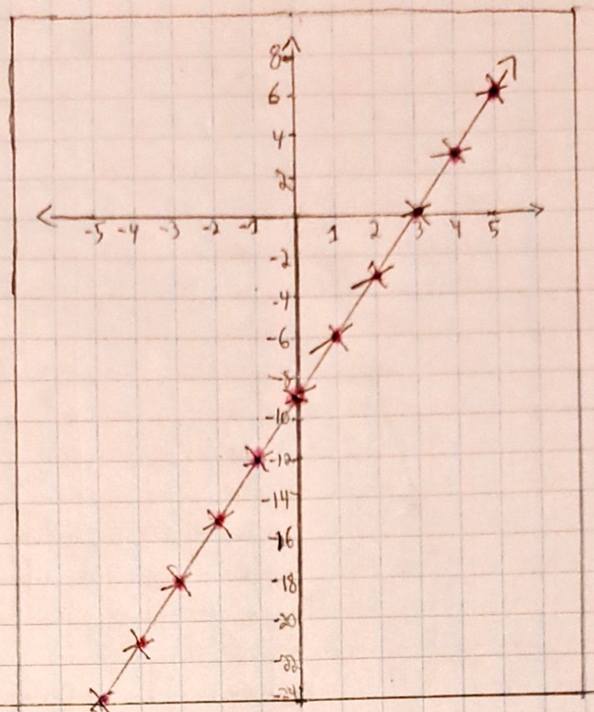a.)

|  |  |
| --- | --- |
| X | Y |
| -5 | -24 |
| -4 | -21 |
| -3 | -18 |
| -2 | -15 |
| -1 | -12 |
| 0 | -9 |
| 1 | -6 |
| 2 | -3 |
| 3 | 0 |
| 4 | 3 |
| 5 | 6 |

b.)

|  |  |
| --- | --- |
| **X** | **Y** |
| -5 | 18.5 |
| -4 | 16 |
| -3 | 13.5 |
| -2 | 11 |
| -1 | 8.5 |
| 0 | 6 |
| 1 | 3.5 |
| 2 | 1 |
| 3 | -1.5 |
| 4 | -4 |
| 5 | -6.5 |

c.)

|  |  |
| --- | --- |
| **X** | **Y** |
| -5 | 7.5 |
| -4 | 9 |
| -3 | 9.5 |
| -2 | 9 |
| -1 | 7.5 |
| 0 | 5 |
| 1 | 1.5 |
| 2 | -3 |
| 3 | -8.5 |
| 4 | -15 |
| 5 | -22.5 |

d.)

|  |  |
| --- | --- |
| **X** | **Y** |
| 2 | -0.58 |
| 3 | 0.23 |
| 4 | 0.82 |
| 5 | 1.31 |
| 6 | 1.74 |
| 7 | 2.12 |
| 8 | 2.47 |
| 9 | 2.79 |
| 10 | 3.09 |
| 11 | 3.38 |
| 12 | 3.65 |

1. **Print(math.ceil(3.5)) = 4**

The math.ceil function will round up to the nearest whole integer.

**Print(math.floor(3.5) = 3**

The math.floor function will round down to the nearest whole integer.

**Print(math.sqrt(25)) = 25**

The math.sqrt function will the take the square root of the number in the function.

**Print(math.factorial(4)) = 24**

The math.factorial function will compute the factorial of whatever integer is entered.

**Print(math.fabs(-1)) = 1**

The math.fabs function will return the absolute value of whatever number is entered.